Struggle performances by protests claims crosstabulation controlled by its centralization in the capital city of Lima, Peru (1980-2020)
José Manuel Mejía Villena

Abstract

Introduction and Theory
Contentious performances are defined as the forms of struggle learned historically which certain populations and collective actors have disposable to mobilize for certain claims which antagonize or challenge the interests of specific targets (Tilly and Tarrow 2010, 14). In this sense, for instance, labor unions learned, created and adapt certain struggle performances as marches and strikes, routinizing and sometimes innovating its repeated contention against corporations for the payment of unpaid salaries, and another kind of performances to challenge the state for a rise in the wages as road blockades and general strikes.
The execution of certain struggle performances by certain collective actors could depend on the target to which the protests are oriented, but also by the claim which also implies a challenge to the stablished relations in regard of the interests of certain polity members as elites with access to state decisions, which are antagonistic to the revindication of the challenger's claims (McAdam, Tarrow and Tilly 2001).
The following research question was build considering a covariation of the struggle performances by protest claims: how struggles of performances variates by protests claims in Peruvian protests events registered between 1980 and 2020? The frequency and percentage crosstabulations define 24 cells which combine the expected and observed frequencies and/or percentages on the junction of the sets of protests events constituted by 4 and 6 typological categories defined for the variables struggle performances and protest claims as discrete values of these two nominal variables. The interpretation of the chi-square Pearson coefficient test and the Cramer's V measure of association is supportive for the rejection of the null hypothesis of non-covariation of struggle performances by protest claims as two discrete variables.
The introduction of a third variable as a control in the crosstabulation of struggle performances by protest claims segmented the population of a 21,921 total protest events registered in the Peruvian Protests Database (BPSP) (Arce 2014) in two subsets of 11,206 protest events centralized in the capital city of Lima, and 10,715 protest events executed in the countryside for the period 1980 and 2020. The chi-square Pearson and Cramer's V coefficients improves the size of the effect of protests claims on the struggle performances selection and execution depending on the centralization of the protest on the capital city or its occurrence in the countryside.

Data and Methods

Sample and population
The unit of analysis of Protest Event Analysis (PEA) (Ruchts …) and the construction of contentious event catalogues (Tilly 2002) based on the registration of certain features of those events mainly relative to who protests whom, how and why (Wada 2002).
The Peruvian Protests Database (BPSP are its Spanish acronyms) was developed mainly under the direction of Moises Arce (2014a, 2014b) codifying 21,921 protest events reported in the three main national newspapers (El Comercio, La Republica and Expreso) since January 1st 1980 and December 31st 2020 based in the revision of each daily edition of those sources in the archives of the Universidad Nacional Mayor de San Marcos and the National Library of Peru.

Conceptual definition and operationalization
As it was stated in the introduction, the struggle performances executed in the revindication of a collective claim implies the challenge to certain targets by certain collective actors by their antagonistic interests expressed in its contention. The methodological choice to consider the protests claims as a discrete independent variable to analyze its covariation effect on the kind of struggle performances executed, is theoretically oriented to rely in the configuration of fields of contention defined by the 6 discrete categories of protests claims.
The field of political contention is defined by the antagonistic interests configurative of certain pairs of challengers and targets of protest, in this sense, the nature of the political claim (why the protests is made?) is a powerful predictor of the struggle performances selection based on the assumption that those performances are part of a set of performances of struggle learned, created and modified in historical sequences of contentious events as protest events, defining certain kinds of performances as more effective and disposable for certain collective actor in their struggle against certain targets for the revindications of the political claims. Which represents their antagonistic interests outside the political decisions taken in the state as the core of the polity or political system.
The variable struggle performances is a result of the recoding of the values showed in the perf_1_code variable frequency table (Table 1) to create four discrete categories: obstructive performances, disruptive performances, radical performances, and others (Table 2), based in the recategorization of its initial values depending on its differentiated potential to obstruct capital circulation in a national economy base (obstructive performances), its potential to disrupt the rate of profit or rate of surplus value of a particular branch of industry or corporation (disruptive performances), its potential to radically demand the satisfaction of protest claims by struggle performances which also involve higher levels of repression (radical performances), and a category of others in which the lowest frequencies were aggregated.
Table 1.
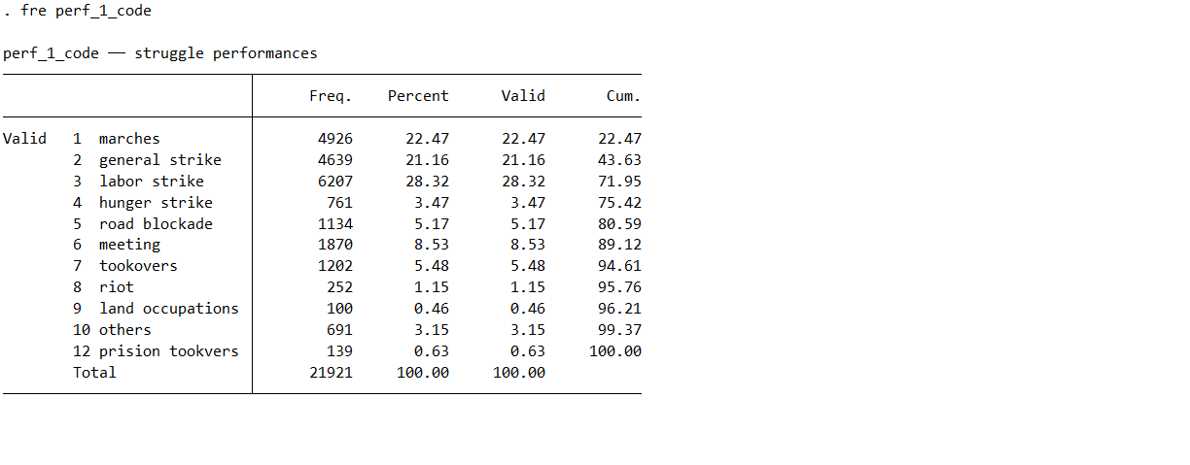
Table 2.
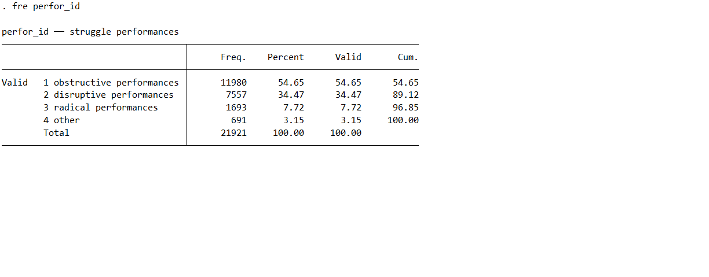
For the construction of the discrete six categories which defines the typology of protest claims (claim_id): labor, environmental, social policy, infrastructure, others and economic policy (Table 4), based on the aggrupation of the original values showed in the Table 3 (dem_id).
Table 3.
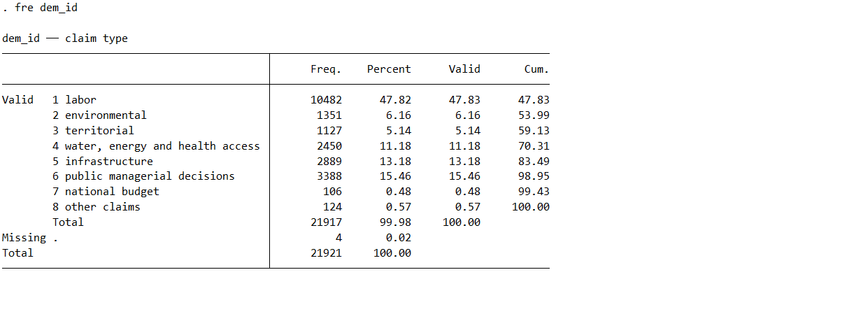
Table 4.
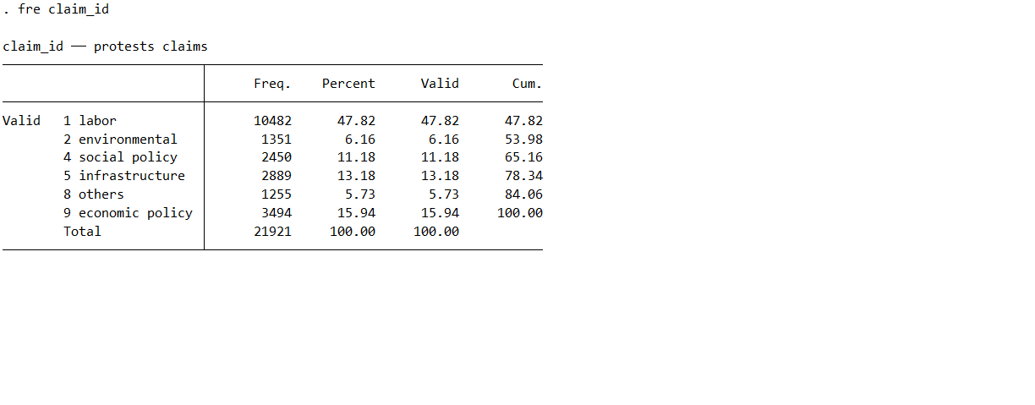
The third variable considered for the control analysis of the crosstabulation of struggle performances by protest claims was protest centralism, defined as the occurrence of the protest event centralized in the capital city of Lima or in the countryside. The .do STATA file attached as an appendix to this paper essay contains the commands applied in the recoding applied to create the discrete variables struggle performances (perf_id) and protest claims (claim_id), and protest centralism (protest_centralism).
Table 5.
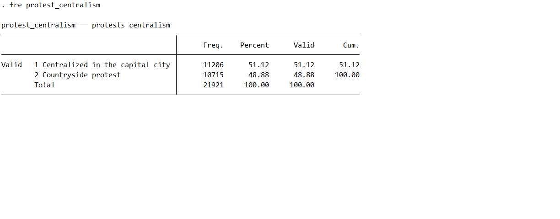

Results
The chi-square test of statistical significance was supportive of the alternative hypothesis of a strong covariation between the protests claims and struggle performances categories and of the rejection of the null hypothesis of non-covariation at a level of significance of 0.001 for 15 degrees of difference. The high magnitude of the value of the chi-square Pearson coefficient in the crosstabulation of struggle performances by protests claims indicates "a greater relative difference between" its observed and expected crosstabulation frequencies (Knoke et al. 2002, 145). Nevertheless, it's necessary to precise that is also an effect of the large size of the sample (Knoke et al. 2002, 147). The chi-square test summarizes the difference across the 24 cells of the Table 3 between the observed and expected frequencies for a degree of difference of 15.
The value of 3.7e+03 calculated by the Stata package chi-square Pearson coefficient test should be read as 3676.19368, as the result of the sum of its 24 components calculated by the difference between the squared difference between the observed and expected frequencies then divided by the expected frequencies of each of the 24 cells of the Table 6, following the formula offered by Knoke et al. (2002, 145).
Table 6.
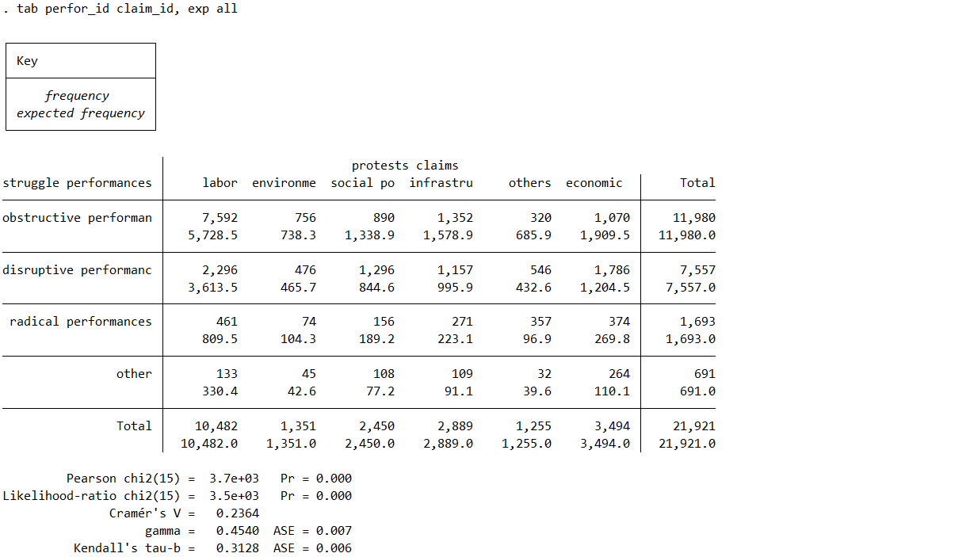
Indeed, considering this calculation for the interpretation of the chi-square Pearson coefficient showed in Table 6, we can conclude that the critical value of 37.697 chi square coefficient value for a degree difference of 15 (Knoke et al. 2002, 459-460) was highly superseded by the 3676.19368 value (3.7e+03 in Table 3 Stata exported result) and indeed reject the null hypothesis of no covariation between the discrete variables struggle performances and protests claims in a level of significance of 0.001. The Table 7 Cramer's V coefficient of 0.2364 also can be interpreted as indicative of a medium effect size of the discrete variable protests claims over the prediction of the covariation of the discrete variable performances of struggles.
Table 7.
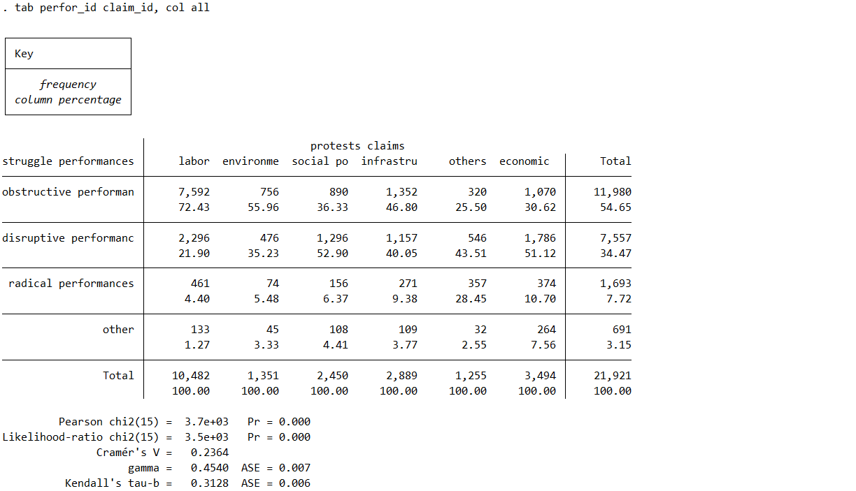
As shown in Table 8 and Table 9, for control analysis, a third variable protest centralism is introduced as a discrete control (measured by the occurrence of the protest in the capital city or in the countryside) in the crosstabulation of struggle performances by protests claims. The comparison of the percentage crosstabulations between the Table 7 and the corresponding ones of Table 8 and Table 9, evidenced the use of certain types of struggle performances depending on the types of protests claims. The differences in the percentage crosstabulations among the 24 cells of the two subsets of protests divided by the variable protest centralism in comparison with the crosstabulation of the same two variables in the total of protests indifferently of their centralism (Table 7).
Table 8 crosstabulation of the first subset of 11,206 protests centralized in the capital city of Lima out of a total of 21,921 protests registered in the Peruvian Protests Database (BPSP) between 1980 and 2020 presented a chi square Pearson coefficient value of 3429.70748 (3.4e+03 in Table 7), calculated with the same method applied for Table 7 crosstabulation offered by Knoke et al. (2002, 145) sufficient to reject the null hypothesis of non-covariance of struggle performances by protest claims considering the critical value of 37.697 in a level of significance of .001.
The Cramer’s V coefficient value of 0.31924 reported in Table 8 is higher than the Cramer’s V coefficient value of the crosstabulation of struggle performances by protests claims without the introduction of the third control variable protest centralism reported in Table 7 (0.2364). In the subset of protests centralized in the capital city of Lima, the covariance of struggle performances by protest claims the Cramer’s V coefficient value of 0.31924 reported and stronger effect size.
Table 8.
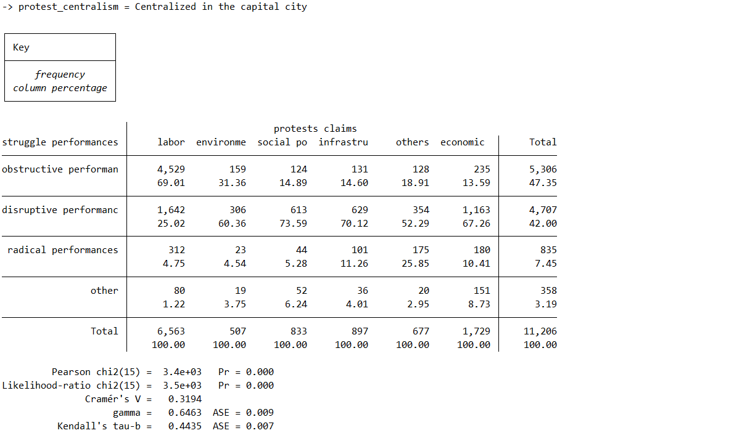
Table 9.
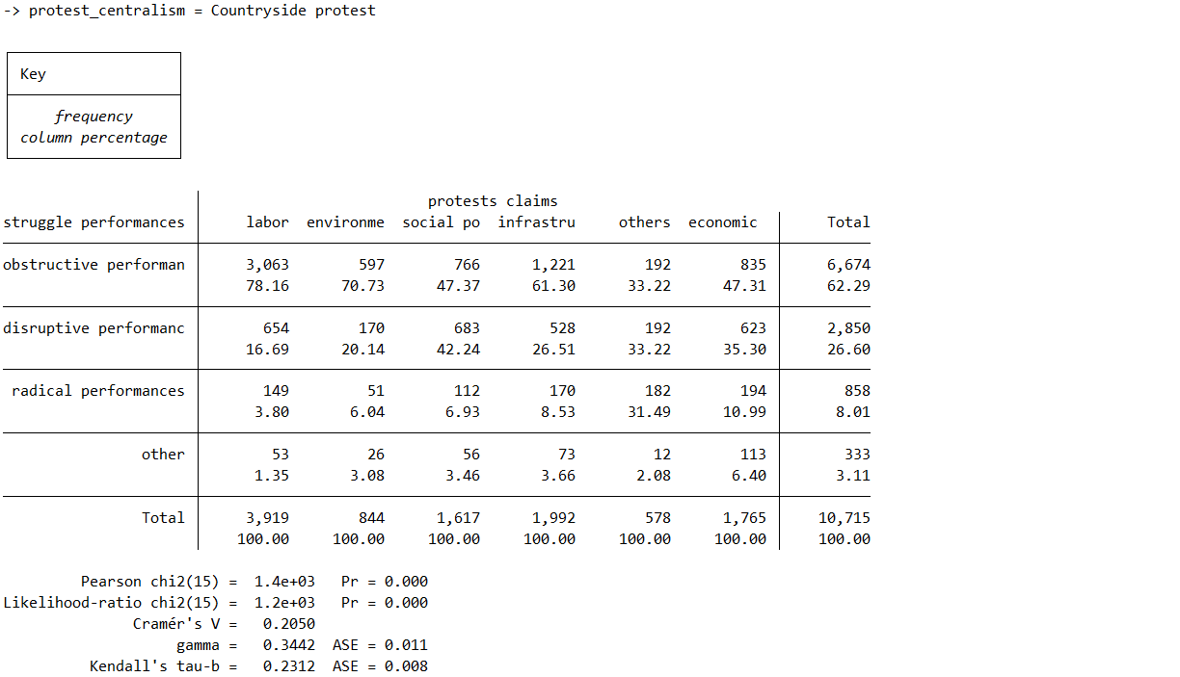
At the final of this last section I provide hypothetical causal mechanism based on the case of studies realized on antimining struggles and in the protests event data building in the archives of national newspapers revision of every daily edition for the periods 2000-2006 and 2016-2020, to complete theoretically the interpretation of the changes in the percentage crosstabulation of struggle performances by protests claims when protests centralism is introduced as a control variable.

Cited references

Appendix: STATA .do file

